Mr. Sabado, Algebra 1 Week 3 Tuesday, February 17, 2015

Home Practice

Due Today:
Extra Credit
Energy Saver

Due 2/18:
Assignment #8:
Evaluating Functions Worksheet

Quiz Friday!!!


Agenda

- Opener Sheet Warm-Up

- Lesson: Function Notation

- Class Work

- Homework

Warm-Up

Simplify the following 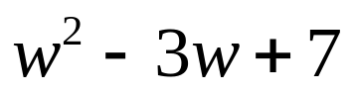
- When w = 5
- When w = 10
- When w = - 3
`whs.saba.do


“It is never too late to be what you might have been.”
- G. Eliot

