Mr. Sabado, Algebra 2 Week 3 Tuesday, February 17, 2015

Home Practice

Due Today:
Assignment #8:
Unit 5 Review Worksheet

Due 2/18:
Assignment #9:
p. 586 #16-30



Agenda

- Opener Sheet
- Warm-Up

- Lesson: One Equals Zero

- Class Work

- Homework


Warm-Up

Simplify

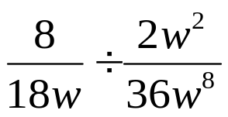

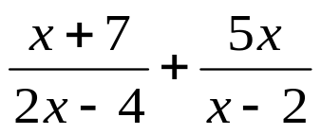
`whs.saba.do

“It is never too late to be what you might have been.”
- G. Eliot

