Mr. Sabado, Algebra 2 Week 11 Friday November 14, 2014

Homework

Due Today:
- Assignment #41
p. 269: 19-33 odd,
and
p. 279: 5-11 odd

Due 11/17 :
- Assignment #42
p. 296: 13-21 odd,
31-39 odd, 49, 50, 52-55, 57

Agenda

- Warm-Up
- HW Questions
- Turn in Packet

- Lesson: QF and Discriminant

- Class Work
- Homework
- Return Graded Work



Warm-Up

Solve
- 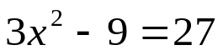

2. 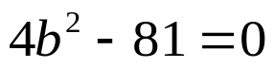

whs.saba.do



“It is never too late to be what you might have been.”
- G. Eliot

