Mr. Sabado, Algebra 2 Week 18 Friday, June 5, 2015

Home Practice

Due Today:
Assignment #68:
p. 856: 3-27 odd, 30-34

Due 6/8:
Assignment #69:
p. 862: 3-31, 39-41


Agenda

- Warm-Up
- Turn in Opener Packet

- Lesson: Angles and Their Measure

- Class Work

- Homework

- Return Graded Work

Warm-Up

Find the Inverse of
1) 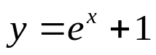

Determine the y intercept of
2. 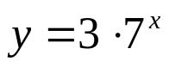

`whs.saba.do

+

If

“It is never too late to be what you might have been.”
- G. Eliot

