Mr. Sabado, Algebra 1 Week 8 Friday, October 24, 2014

Homework

Due Today:
- Assignment #33:
Quiz Review: Solving Equations

Due 10/26:
- Assignment #34:
Activity 29 Worksheet

Quiz on Friday!!!

Agenda

- Warm-Up
- HW Questions
- Turn in Opener Packet

- Quiz: Solving Two Step Equations

- Class work
- Homework
- Return Graded Work


Warm-Up

Solve

- 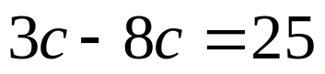

- 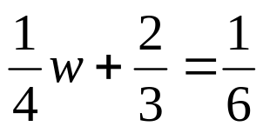

whs.saba.do

“It is never too late to be what you might have been.”
- G. Eliot

