Mr. Sabado, Algebra 2 Week 7 Wednesday, March 8, 2016

Home Practice

Due Today:
Assignment #27:
7.1-7.4 Review

Due 3/9:
Assignment #28:
p. 504 (45-57)

Quiz on Wednesday (3/8)!!!

Agenda

- Warm-Up
- HW Questions

- Class Work

- Quiz: Logarithmic Functions

- Homework

- Return Graded Work

Warm-Up

Find the inverse of the given function.
3) 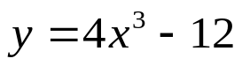



“It is never too late to be what you might have been.”
- G. Eliot

