Mr. Sabado, Algebra 2 Week 10 Monday, October 24, 2016

Homework

Due Today:
- Assignment #39
Quadratics Review Worksheet

Due 10/25
- Assignment #40
p. 255 (3-23 odd)
p. 263 (3-31 odd)



Agenda

- Warm-Up

- Lesson: Factoring

- Class Work

- Homework

- Return Graded Work

Warm-Up

Find the area of the rectangle.
1. 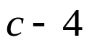
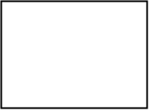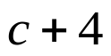

2. Factor out the GCF
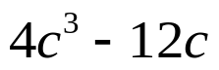



Reminder: The bell does not dismiss you, I dismiss you.
- Mr. Sabado

