Mr. Sabado, Algebra 2 Week 11 Monday, October 31, 2016

Homework

Due Today:
- Assignment #44
p. 288: 13-27, 35, 50, 53

Due 11/1
- Assignment #45
p. 288: 9-12, 28-34, 37, 51, 55, 69-74




Agenda

- Warm-Up

- Lesson: Completing the Square

- Class Work

- Homework

- Return Graded Work

Warm-Up

Simplify
- 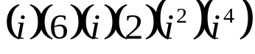

2)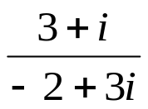

Solve by factoring
3. 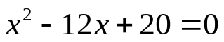

Algebra 2 Online Textbook: 2606518-10
classzone.com



Reminder: The bell does not dismiss you, I dismiss you.
- Mr. Sabado

