Mr. Sabado, Algebra 2 Week 13 Tuesday, November 15, 2016

Homework

Due Today:
- Assignment #54
p. 304: (3-23 odd, 18)

Due 11/16
- Assignment #55
p. 312: (4-9, 15-17, 19-27 odd, 26)

- Assignment #56
Unit 3 Test Review

Unit 3 Test on 11/17 and 11/18!!!




Agenda

- Warm-Up

- Notes: Writing Quadratic Functions

- Class Work: Solving Equations

- Homework

- Return Graded Work

Warm-Up

Simplify

- 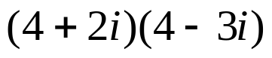
- 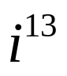
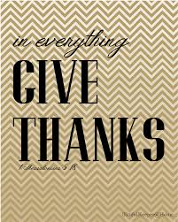

“It is never too late to be what you might have been.”
- G. Eliot

