Mr. Sabado, Algebra 2 Week 11 Friday, November 4, 2016

Homework

Due Today:
- Assignment #48
Quadratics Word Problems Review

Due 11/7
- Assignment #49
Graphing Review

Quiz on Friday!!!

- Assignment #45
p. 288: 9-12, 28-34, 37, 51, 55, 69-74



Agenda

- Warm-Up
- Turn in Opener Packet

- Quiz: Solving Quadratics

- Quiet Activity

- Homework
- Return Graded Work

Warm-Up

Simplify
- 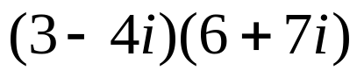
- Solve
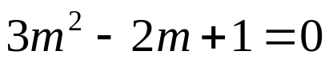

Algebra 2 Online Textbook: 2606518-10
classzone.com



Reminder: The bell does not dismiss you, I dismiss you.
- Mr. Sabado

