Mr. Sabado, Algebra 2 Week 12 Monday, November 7, 2016

Homework

Due Today:
- Assignment #49
Graphing Review

Due 11/8
- Assignment #50
p. 249 (3-11 odd, 12, 33-35, 51)
Unit 3 Test on 11/17 and 11/18!!!
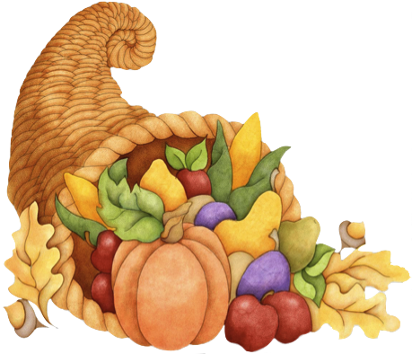
- Assignment #45
p. 288: 9-12, 28-34, 37, 51, 55, 69-74



Agenda

- Warm-Up

- Review: Graphing Quadratics: Vertex Form

- Class Work

- Homework

- Return Graded Work

Warm-Up

- Graph and state the end behaviors.
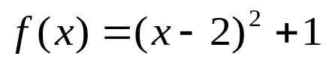

Algebra 2 Online Textbook: 2606518-10
classzone.com



Reminder: The bell does not dismiss you, I dismiss you.
- Mr. Sabado

