Mr. Sabado, Algebra 2 Week 12 Tuesday, November 8, 2016

Homework

Due Today:
- Assignment #50
p. 249 (3-11 odd, 12, 33-35, 51)

Due 11/9
- Assignment #51
p. 249 (13-23 odd, 22, 37, 39, 41, 53)
Unit 3 Test on 11/17 and 11/18!!!
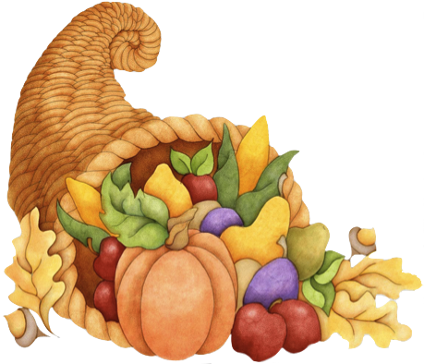
- Assignment #45
p. 288: 9-12, 28-34, 37, 51, 55, 69-74



Agenda

- Warm-Up

- Lesson: Graphing Quadratics: Standard Form

- Class Work

- Homework

- Return Graded Work

Warm-Up

Solve
1. 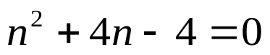

2. Find the discriminant and state the number and type of solutions
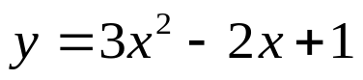

Algebra 2 Online Textbook: 2606518-10
classzone.com



Reminder: The bell does not dismiss you, I dismiss you.
- Mr. Sabado

