Mr. Sabado, Algebra 2 Week 12 Wednesday, November 9, 2016

Homework

Due Today:
- Assignment #51
p. 249 (13-23 odd, 22, 37, 39, 41, 53)

Due 11/10
- Assignment #52
p. 240 (19-39 odd, 20)

Unit 3 Test on 11/17 and 11/18!!!

- Assignment #45
p. 288: 9-12, 28-34, 37, 51, 55, 69-74



Agenda

- Warm-Up

- Lesson: Graphing Quadratics: Intercept Form

- Class Work

- Homework

- Return Graded Work

Warm-Up

- Graph the following quadratic function.
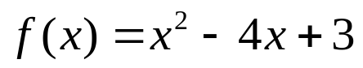

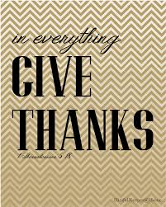

Reminder: The bell does not dismiss you, I dismiss you.
- Mr. Sabado

