Mr. Sabado, Alg. 1CD Week 6 Thursday, October 1, 2015

Homework

Due Today:
No Homework

Due 10/2:
- Assignment #24:
Opposites and Absolute Value Worksheet

Agenda

- Seating Chart
- Warm-Up

- Exploration: Drop and Catch

- Class Work

- Homework

Warm-Up

Simplify
- 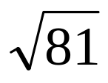

- 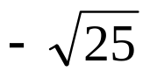

- 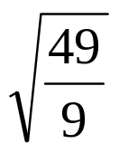

whs.saba.do



“It is never too late to be what you might have been.”
- G. Eliot

