Mr. Sabado, Alg. 1CD Week 7 Monday, October 5, 2015

Homework

Due Today:
- Assignment #25:
Review Worksheet

Due 10/6:
- Assignment #26:
Shading Grids Worksheets

Agenda

- Warm-Up

- Discovery Lesson: Shading Grids

- Class Work

- Homework

Warm-Up

Solve
1. 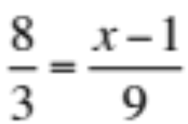

2. 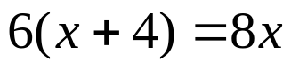

Simplify
3. 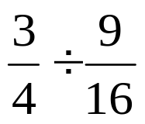

whs.saba.do



“It is never too late to be what you might have been.”
- G. Eliot

