Mr. Sabado, Alg. 1CD Week 7 Tuesday, October 6, 2015

Homework

Due Today:
- Assignment #26:
Shading Grids Worksheets

Due 10/7:
- Assignment #27:
Review Worksheet

Agenda

- Warm-Up

- Complete Discovery Lesson: Shading Grids

- Class Work

- Homework

Warm-Up

Graph the following
- 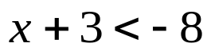

Solve
- 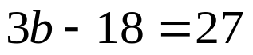

- 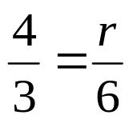

whs.saba.do



“It is never too late to be what you might have been.”
- G. Eliot

