Mr. Sabado, Alg. 1CD Week 7 Thursday, October 8, 2015

Homework

Due Today:
- Assignment #28:
Review Worksheet

Due 10/9:
- Assignment #29:
Linear or Exponential? Part 2

Quiz on Friday!!!

Agenda

- Warm-Up
- Homework Questions

- Lesson: Linear vs. Exponential

- Class Work

- Homework

Warm-Up
1. Solve by any method
- 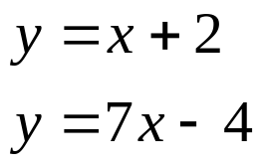

- 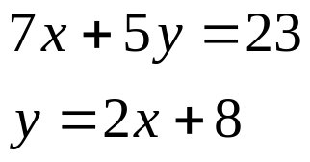


whs.saba.do

“It is never too late to be what you might have been.”
- G. Eliot

