Mr. Sabado, Alg. 1CD Week 7 Friday, October 9, 2015

Homework

Due Today:
- Assignment #29:
Linear or Exponential? Part 2

Due 10/12:
- Extra Credit:
It’s Gonna Get Choo

Quiz on Friday!!!

Agenda

- Warm-Up
- Turn in Packet

- Quiz: Skills

- Quiet Activity

- Return Unit Test

- Homework

Warm-Up
Solve

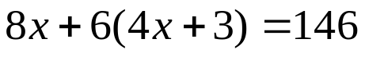

Solve by elimination
- 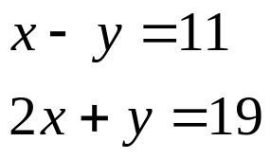


whs.saba.do

“It is never too late to be what you might have been.”
- G. Eliot

