Mr. Sabado, Alg. 1CD Week 5 Monday, September 21, 2015

Homework

Due Today:
- Assignment #16:
Why did the plum…

Due 9/22:
- Assignment #17:
Independent Practice

Quiz Friday!!!

Agenda

- Warm-Up
- New Opener Sheet

- Lesson: Solving Systems by Elimination

- Homework

- Return Graded Work
l

Warm-Up
Solve by graphing or substitution
- 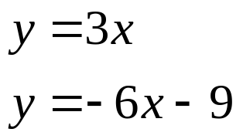

- 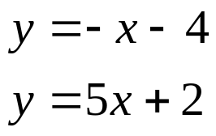

whs.saba.do



“It is never too late to be what you might have been.”
- G. Eliot

