Mr. Sabado, Alg. 1CD Week 5 Tuesday, September 22, 2015

Homework

Due Today:
- Assignment #17:
Independent Practice

Due 9/23:
- Assignment #18:
The Real Number Line

Quiz Friday!!!

Agenda

- Warm-Up

- Review: Solving Systems by Elimination

- Homework

- Return Graded Work
l

Warm-Up
Solve by elimination
- 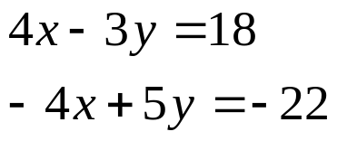

- 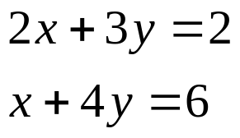

whs.saba.do



“It is never too late to be what you might have been.”
- G. Eliot

