Mr. Sabado, Alg. 1CD Week 5 Thursday, September 24, 2015

Homework

Due Today:
- Assignment #19:
Elimination Handout

Due 9/25:
- Assignment #20:
Elimination Handout

Quiz Friday!!!

Agenda

- Warm-Up

- Review: Solving Systems by Elimination

- Class Work

- Homework

- Return Graded Work
l

Warm-Up
Solve the Following

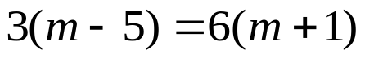
Solve by any method
- 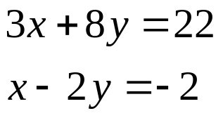

whs.saba.do



“It is never too late to be what you might have been.”
- G. Eliot

