Mr. Sabado, Alg. 1CD Week 5 Friday, September 25, 2015

Homework

Due Today:
- Assignment #20:
Review Handout

Due 9/28:
- Assignment #21:
Bob’s Review Handout

Quiz Friday!!!
Unit Test 1 on Tuesday (9/29)

Agenda

- Warm-Up
- Turn in Packet

- Quiz: Solving Systems by Elimination

- Quiet Activity

- Homework

- Return Graded Work
l

Warm-Up

Solve by any method
- 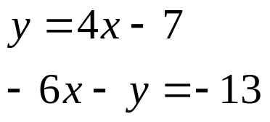

whs.saba.do



“It is never too late to be what you might have been.”
- G. Eliot

