Mr. Sabado, Alg. 1CD Week 6 Monday, September 28, 2015

Homework

Due Today:
- Assignment #21:
Bob’s Review Handout

Due 9/29:
- Assignment #22:
Unit 1 Review

Unit Test 1 moved to Wednesday (9/30)

Agenda

- Opener Sheet
- Warm-Up
- Turn in Packet

- Unit Test Review: Solving Systems by Elimination

- Homework

- Return Graded Work
l

Warm-Up

Solve by any method
- 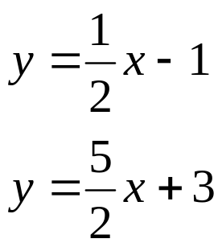

whs.saba.do



“It is never too late to be what you might have been.”
- G. Eliot

