Mr. Sabado, Alg. 1CD Week 6 Tuesday, September 29, 2015

Homework

Due Today:
- Assignment #22:
Unit 1 Review

Due 9/30:
- Assignment #23:
Unit 1 Review #2 & Systems Full Circle

Unit Test 1 on Wednesday (9/30)

Agenda

- Warm-Up
- HW Questions

- Unit Test Review: Solving Systems

- Class Work

- Homework

- Return Graded Work
l

Warm-Up

Solve by any method
- 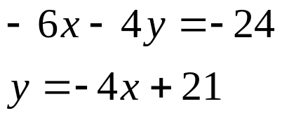

whs.saba.do



“It is never too late to be what you might have been.”
- G. Eliot

