Mr. Sabado, Algebra 2 Week 6 Tuesday, February 28, 2017

Home Practice

Due Today:
Assignment #22:
p. 496 (35-41, 45, 47, 49, 69-74)

Due 3/1:
Assignment #23:
7.1-7.3 Review Worksheet

Quiz on Wednesday!!!



Agenda

- Warm-Up

- Spiral Review

- Homework: 7.1-7.3 Quiz Review

- Exit Ticket

- Return Graded Work

Warm-Up

Find the inverse of
- 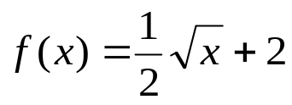

- 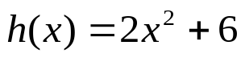

whs.saba.do

“It is never too late to be what you might have been.”
- G. Eliot

