Mr. Sabado, Algebra 2 Week 18 Friday, January 8, 2016

Homework

Due Today:
- Opener Packet:
Week 18

Due 1/13:
- Game Tank Lab



Agenda

- Warm-Up
- Turn Week 18 Packet

- Performance Task: Polynomials

- Return Graded Work

Warm-Up

Graph the following:
- 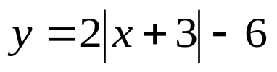

2. 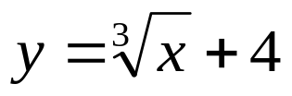
`

yes

“It is never too late to be what you might have been.”
- G. Eliot

