Mr. Sabado, Algebra 1 Week 9 Tuesday, March 31, 2015

Home Practice

Due Today:
Assignment #28:
Test Review Part 1

Due 3/31:
Assignment #29:
Test Review Part 2

Unit 1 Test on Wednesday!!!


Agenda

- Opener Sheet
- Warm-Up
- HW Questions

- Station Review Continued: Functions

- Class Work
- Homework
- Return Graded Work

Warm-Up

Use the following graph to determine the answers
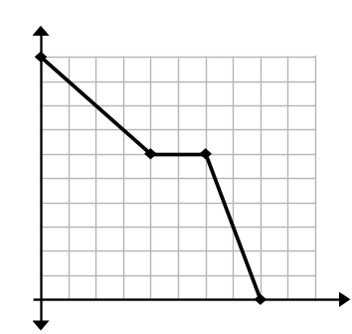
- Is it a function? Explain your answer in complete sentences.

2) Over what interval is the graph decreasing?
whs.saba.do


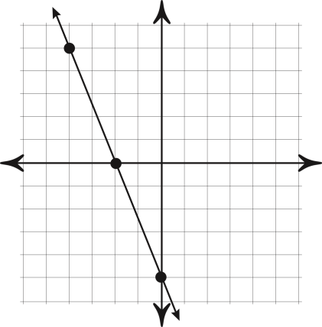

“It is never too late to be what you might have been.”
- G. Eliot
