Mr. Sabado, Algebra 1 Week 9 Wednesday, April 1, 2015

Home Practice

Due Today:
Assignment #29:
Test Review Part 2

Due 4/2:
No HW

Unit 1 Test Today!!!


Agenda

- Warm-Up
- HW Questions

- Unit 1 Test: Functions

- Quiet Activity

- Return Graded Work

Warm-Up

Write: Unit 1 Test in your Opener Box.

Take out your pencil. Clear off your desk and wait for the test.

whs.saba.do


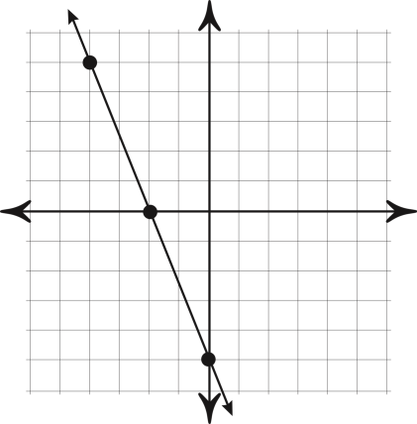

“It is never too late to be what you might have been.”
- G. Eliot
