Mr. Sabado, Algebra 1 Week 11 Monday, April 13, 2015

Home Practice

Due Today:
No HW

Due 4/14:
Assignment #31:
How Many Cups?



Agenda

- Warm-Up
- Seating Chart

- Stacking Cups Activity

- Class Work

- Homework

- Return Graded Work

Warm-Up

Simplify
- 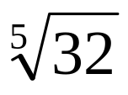

- 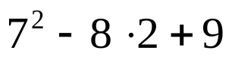
whs.saba.do

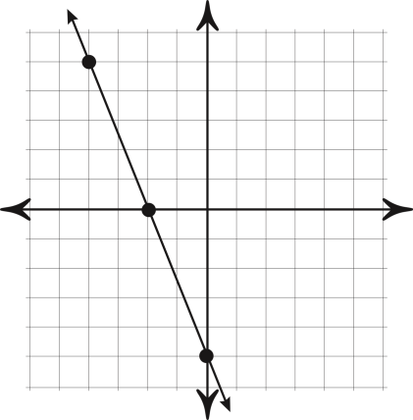

“It is never too late to be what you might have been.”
- G. Eliot
