Mr. Sabado, Algebra 1 Week 11 Tuesday, April 14, 2015

Home Practice

Due Today:
Assignment #31:
How Many Cups? Questions to Ponder

Due 4/15:
Assignment #32:
How Many Cups? The Homework



Agenda

- Warm-Up

- Stacking Cups Activity Continued

- Class Work

- Homework

- Return Graded Work

Warm-Up

Simplify the following when x = 5 and y = -3
- 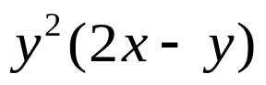
- 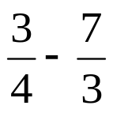
- Simplify
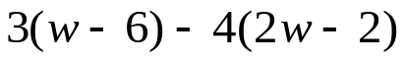
whs.saba.do

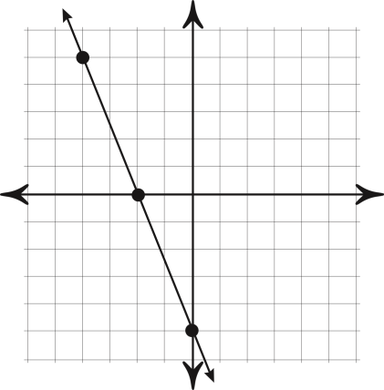

“It is never too late to be what you might have been.”
- G. Eliot
