Mr. Sabado, Algebra 1 Week 11 Wednesday, April 15, 2015

Home Practice

Due Today:
Assignment #32:
How Many Cups? The Homework

Due 4/16:
Assignment #33:
Patterns Practice #1



Agenda

- Warm-Up

- Lesson: Patterns

- Class Work

- Homework

- Return Graded Work

Warm-Up

Solve

- 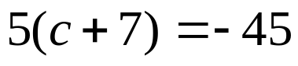

- 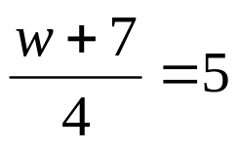

whs.saba.do

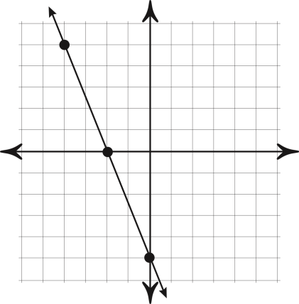

“It is never too late to be what you might have been.”
- G. Eliot
