Mr. Sabado, Algebra 1 Week 11 Thursday, April 16, 2015

Home Practice

Due Today:
Assignment #33:
Patterns Practice #1

Due 4/17:
Assignment #34:
Patterns Practice #2



Agenda

- Warm-Up

- Lesson Continued: Patterns

- Exit Ticket

- Homework

- Return Graded Work

Warm-Up

Solve

- 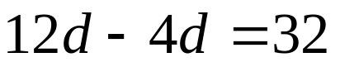

- 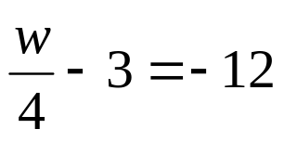

whs.saba.do

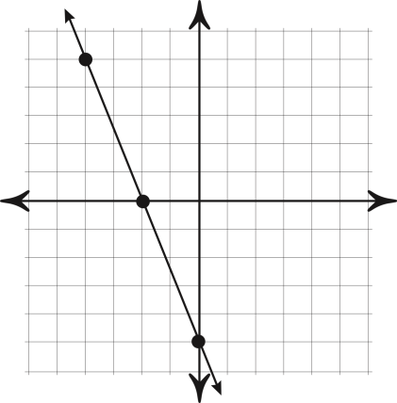

“It is never too late to be what you might have been.”
- G. Eliot
