Mr. Sabado, Algebra 1 Week 11 Friday, April 17, 2015

Home Practice

Due Today:
Assignment #34:
Patterns Practice #2

Due 4/20:
E.C.
It Works for Peanuts



Agenda

- Warm-Up
- Turn in Opener Packet

- Quiz: Patterns, Rate of Change

- Quiet Activity

- Homework

- Return Graded Work

Warm-Up

Solve each equation

- 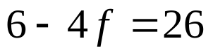

- 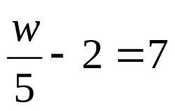

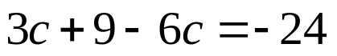
whs.saba.do

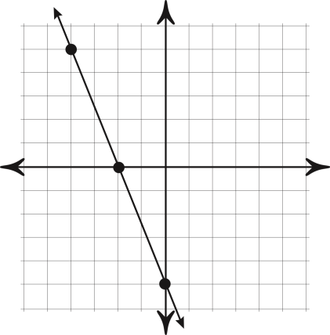

“It is never too late to be what you might have been.”
- G. Eliot
