Mr. Sabado, Algebra 1 Week 9 Thursday, April 2, 2015

Home Practice

Due Today:
No HW

Due 4/3:
Assignment #30:
Functions + Solving Review
Opener Packet

Unit 1 Test Make-Up Today!!!


Agenda

- Warm-Up

- Unit 1 Test (make-up): Functions

- Class Work

- Homework

- Return Graded Work

Warm-Up

Solve

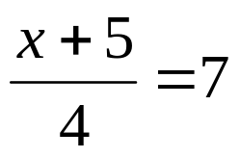

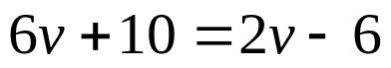
whs.saba.do


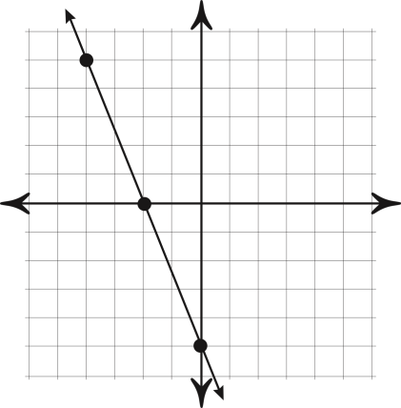

“It is never too late to be what you might have been.”
- G. Eliot
