Mr. Sabado, Algebra 1 Week 9 Friday, April 3, 2015

Home Practice

Due Today:
Assignment #30:
Functions + Solving Review
Opener Packet

Due 4/13:
No HW


Agenda

- Warm-Up

- Turn in Opener Packet

- Extra Credit
- Return Graded Work


Warm-Up

Solve then graph
- 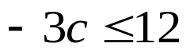
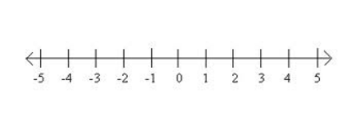
Simplify
- 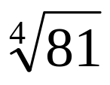

- 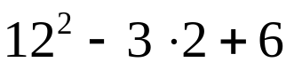
whs.saba.do

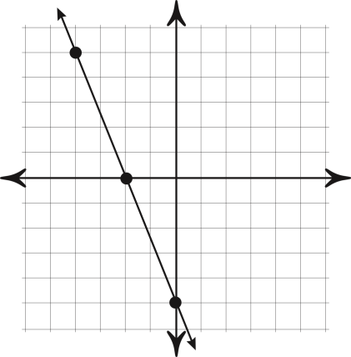

“It is never too late to be what you might have been.”
- G. Eliot
