Mr. Sabado, Algebra 2 Week 11 Monday, April 13, 2015

Home Practice

Due Today:
No HW

Due 4/13:
Assignment #36:
p. 686: 3-10, 11-29 odd, 56, 62-64



Agenda

- Seating Chart
- Warm-Up

- Lesson: The Counting Principle

- Class Work

- Homework

- Return Graded Work

Warm-Up

Evaluate the following

- 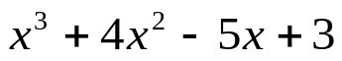 when x = - 3

- 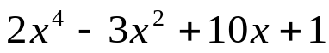 when x = 2

`whs.saba.do


+

If

“It is never too late to be what you might have been.”
- G. Eliot

p.686 (3-10, 11-296 odd, 56, 62-65

