Mr. Sabado, Algebra 2 Week 11 Tuesday, April 14, 2015

Home Practice

Due Today:
Assignment #36:
p. 686: 3-10, 11-29 odd, 56, 62-64

Due 4/15:
Assignment #37:
p. 687: 35-53 odd, 67-69, 74-77

Quiz on Friday!!!


Agenda

- Warm-Up

- Lesson Continued: Permutations

- Class Work

- Homework

- Return Graded Work

Warm-Up
- A men’s department store sells 3 different suit jackets, 6 different shirts, 8 different ties, and 4 different pairs of pants. How many different suits consisting of a jacket, shirt, tie, and pants are possible?

Evaluate
2.
3. 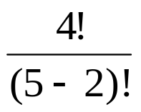

`whs.saba.do


+

If

“It is never too late to be what you might have been.”
- G. Eliot

p.686 (3-10, 11-296 odd, 56, 62-65

