Mr. Sabado, Algebra 2 Week 11 Wednesday, April 15, 2015

Home Practice

Due Today:
Assignment #37:
p. 687: 35-53 odd, 67-69, 74-77

Due 4/16:
Assignment #38:
p. 694: 7-18, 48-51
p. 697: 1-6

Quiz on Friday!!!


Agenda

- Warm-Up

- Lesson: Combinations

- Class Work

- Homework

- Return Graded Work

Warm-Up

Evaluate
1) 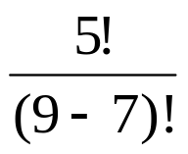

2) 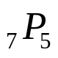

3) 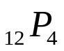

`whs.saba.do


+

If

“It is never too late to be what you might have been.”
- G. Eliot

p.686 (3-10, 11-296 odd, 56, 62-65

