Mr. Sabado, Algebra 2 Week 11 Thursday, April 16, 2015

Home Practice

Due Today:
Assignment #38:
p. 694: 7-18, 48-51
p. 697: 1-6

Due 4/17:
Assignment #39:
p. 695: 19, 20, 23, 25, 31-36, 38-40

Quiz on Friday!!!


Agenda

- Warm-Up

- Lesson: Binomial Theorem

- Class Work

- Homework

- Return Graded Work

Warm-Up

Expand
1) 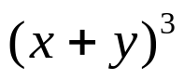
Evaluate
2) 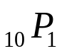

3) 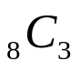

`whs.saba.do


+

If

“It is never too late to be what you might have been.”
- G. Eliot

p.686 (3-10, 11-296 odd, 56, 62-65

