Mr. Sabado, Algebra 2 Week 9 Thursday, April 2, 2015

Home Practice

Due Today:
No HW

Due 4/3:
Assignment #35:
Log + Review Worksheet

Ch. 7 Test Make-Up
Tuesday: Calculator
Wednesday: No Calculator


Agenda

- Warm-Up

- Ch. 7 Test (make-up): Functions

- Class Work

- Homework

- Return Graded Work

Warm-Up

Simplify
- 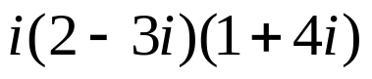
Solve

Find the inverse of
- 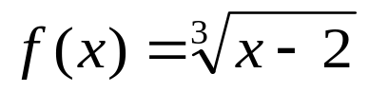

`whs.saba.do


+

If

“It is never too late to be what you might have been.”
- G. Eliot

