Mr. Sabado, Algebra 2 Week 9 Friday, April 3, 2015

Home Practice

Due Today:
Assignment #35:
Log + Review Worksheet

Due 4/13:
No HW



Agenda

- Warm-Up

- Turn in Opener Packet

- Extra Credit
- Return Graded Work
- 

Warm-Up

Evaluate the following

- 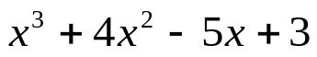 when x = - 4

- 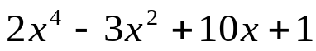 when x = 5

`whs.saba.do


+

If

“It is never too late to be what you might have been.”
- G. Eliot

