Mr. Sabado, Algebra 2 Week 4 Monday, September 12, 2016

Homework

Due Today:
- Assignment #13: Even Functions

Due 9/13:
- Assignment #14: Odd Functions

Unit 1 Test on 9/20!!!

Agenda

- Warm-Up
- HW Questions

- Lesson: Even and Odd Functions

- Class Work

- Homework

- Clock Buddy

Warm-Up
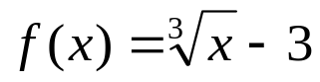

- Find the domain and range.
- Find the y intercept
- Determine the end behavior

whs.saba.do



Reminder: The bell does not dismiss you, I dismiss you.
- Mr. Sabado

