Mr. Sabado, Algebra 2 Week 4 Tuesday, September 13, 2016

Homework

Due Today:
- Assignment #13: Even Functions

Due 9/14:
- Assignment #14: Odd Functions

Unit 1 Test on 9/20!!!

Agenda

- Warm-Up
- HW Questions

- Review: Characteristics + Even and Odd Functions

- Class Work: Choose Your Fate
- Homework

- My Favorite No

Warm-Up

Determine if the following are even, odd, or neither
- 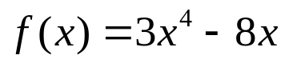
- 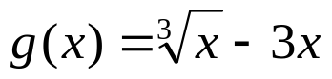

- 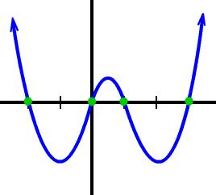

whs.saba.do

Reminder: The bell does not dismiss you, I dismiss you.
- Mr. Sabado

