Mr. Sabado, Algebra 2 Week 4 Thursday, September 15, 2016

Homework

Due Today:
- Assignment #15: Writing Functions

Due 9/16:
- Assignment #16: Piece-wise Functions

Unit 1 Test on 9/20!!!

Agenda

- Warm-Up
- HW Questions

- Lesson: Piecewise Functions

- Class Work
- Homework

Warm-Up

Graph:
- 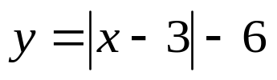
2. 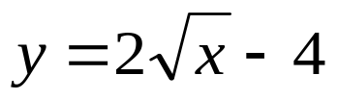

whs.saba.do

Reminder: The bell does not dismiss you, I dismiss you.
- Mr. Sabado

