Mr. Sabado, Algebra 2 Week 5 Monday, September 19, 2016

Homework

Due Today:
- Assignment #17: Unit Review 1

Due 9/20
- Assignment #18: Unit Review 2

Unit 1 Test on 9/20!!!

Agenda

- Warm-Up
- New Opener Sheet

- Review Class Work: Functions

- Return Graded Work

- Homework

Warm-Up

- Graph the following function:

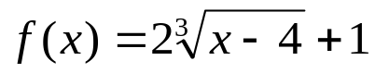

State the following:
2. Domain & Range
3. End behavior
4. Intervals of increase & decrease.

whs.saba.do

Reminder: The bell does not dismiss you, I dismiss you.
- Mr. Sabado

