Mr. Sabado, Algebra 1 Week 7 Tuesday, October 14, 2014

Homework

Due Today:
- Assignment #25:
Activity 15 Worksheet

Due 10/15:
- Assignment #26:
Study Guide: Chapter Test #1

Bring your Textbook every day!!!
Chapter 1 Test on Wednesday (10/15)

Agenda

- Pick Up Opener Sheet
- Warm-Up
- HW Questions

- Practice Test: Foundations of Algebra

- Homework
- Return Graded Work



Warm-Up

Simplify
- 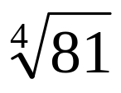

- 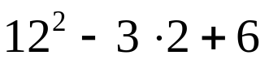

- 

whs.saba.do

“It is never too late to be what you might have been.”
- G. Eliot

