Mr. Sabado, Algebra 1 Week 7 Wednesday, October 15, 2014

Homework

Due Today:
- Assignment #26:
Study Guide: Chapter Test #1

Due 10/16:
- Assignment #27:
Worksheet: Activity 18

Bring your Textbook every day!!!
Chapter 1 Test on Today (10/15)

Agenda

- Warm-Up
- HW Questions

- Unit 1 Test: Foundations of Algebra

- Homework

- Return Graded Work



Warm-Up

Simplify
- 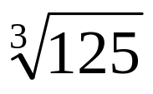

- Clear off your desk and take out a pencil.

- No Calculators are allowed.

whs.saba.do

“It is never too late to be what you might have been.”
- G. Eliot

