Mr. Sabado, Algebra 1 Week 7 Thursday, October 16, 2014

Homework

Due Today:
- Assignment #27:
Worksheet: Activity 18

Due 10/17:
- Assignment #28:
Page 75: 21-36, 56-58

Bring your Textbook every day!!!

Agenda

- Warm-Up

- Lesson Exploration: Equations

- Exit Ticket

- Homework

- Return Graded Work



Warm-Up

Simplify
- 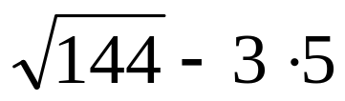

- 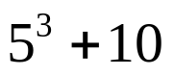

- 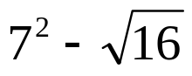

whs.saba.do

“It is never too late to be what you might have been.”
- G. Eliot

