Mr. Sabado, Algebra 1 Week 7 Friday, October 17, 2014

Homework

Due Today:
- Assignment #28:
Page 75: 21-36, 56-58

Due 10/20:
- Assignment #29:
Mixed Review Worksheet

Bring your Textbook every day!!!

Agenda

- Warm-Up
- Turn in Opener Packet

- Lesson: Equations

- Math Sprint

- Homework

- Return Graded Work



Warm-Up

Solve each equation by substitution
- 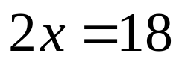

- 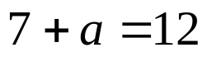

- 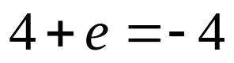

whs.saba.do

“It is never too late to be what you might have been.”
- G. Eliot

