Mr. Sabado, Alg. 1CD Week 2 Monday, August 31, 2015

Homework

Due Today:
- Assignment #3: T-Shirt Design

Due 9/1:
- Assignment #4: Fancy T-Shirt Handout

Agenda

- Warm-Up
- Opener Sheet Expectations

- Class Work: Custom T-shirt

- Homework

- Practice Dismissal

Warm-Up

Simplify the following 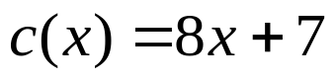
- 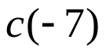
- 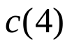

whs.saba.do



“It is never too late to be what you might have been.”
- G. Eliot

